James Hill

event driven programs

Purpose
The purpose of the website is to sell high end clothing, there will be very expensive clothing on sale on the website, there will be one main page that has all the clothing on it and the other three pages will be the home page, contact and checkout page, the checkout page will allow things to be added and removed to and from it, the contacts page has a place to add information and put a review or complaint etc.

Fonts, colours, size
The fonts of the page will be monospace and they will be in the wildcard tag for CSS to allow it to make every bit of text on the website all the same so there is no different text and it looks smart. The size of the text will be what is set from the CSS and what is chosen from the selected CSS file and they are mainly chosen by what looks the best and how it fits on the screen.

Page Designs
The page designs are taken from a website I made from scratch and will be reused from what I created from a task before.

This is the screen shot of what the page looks from when I first created it and coded it but obviously it will look a lot different now with it being colour coordinated.

Test | Description | Method | Outcome | Screenshot
Shopping basket | I wanted to check if the items would be added to my basket | Add the JavaScript code for the checkout and implement the code to link the coding to the code | It worked and the products can be added to the basket | 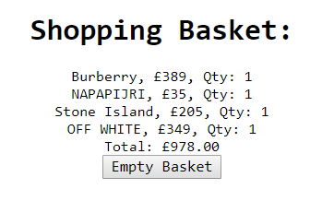
Making the text all the font | I wanted to make every piece of text the same font to make it smart and clean | I used the wild card code in the CSS file | Yes, the text on the pages are all monospace | 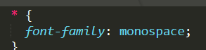
“ | “ |  | It wouldn’t work at first due to there being speech marks around monospace which make the program not recognise the font | 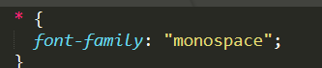
The page background wouldn’t fill the screen | There wasn’t a flow of the background it finished shorter than the page | Add a style section to the html tag and a height feature | It worked and filled the screen. | 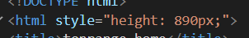

Code

Home
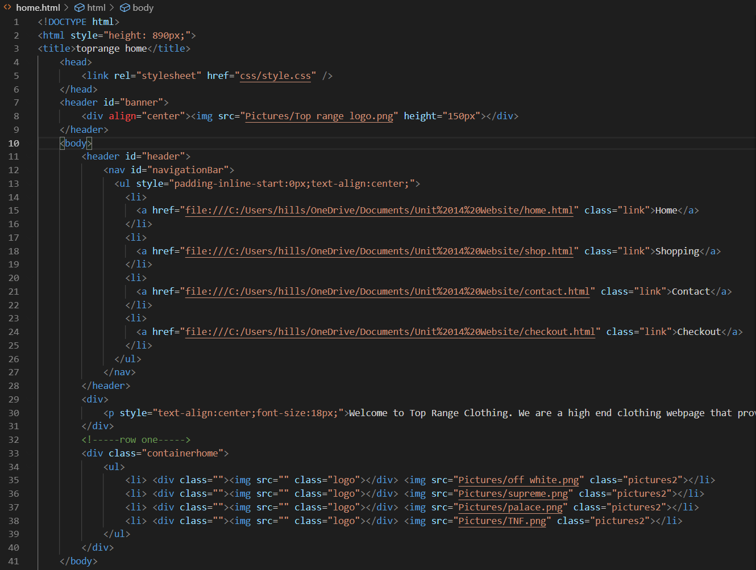

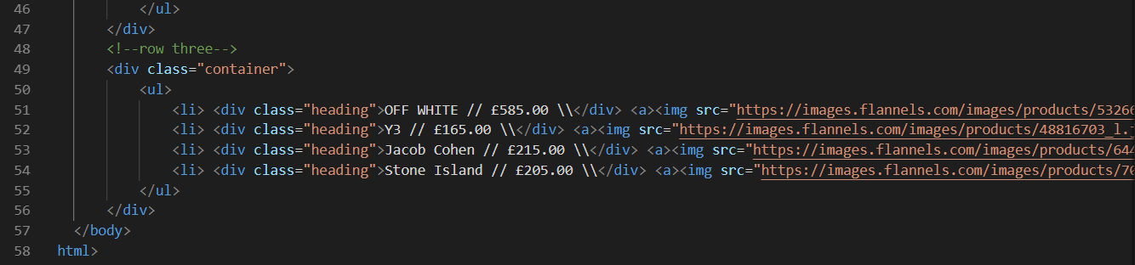
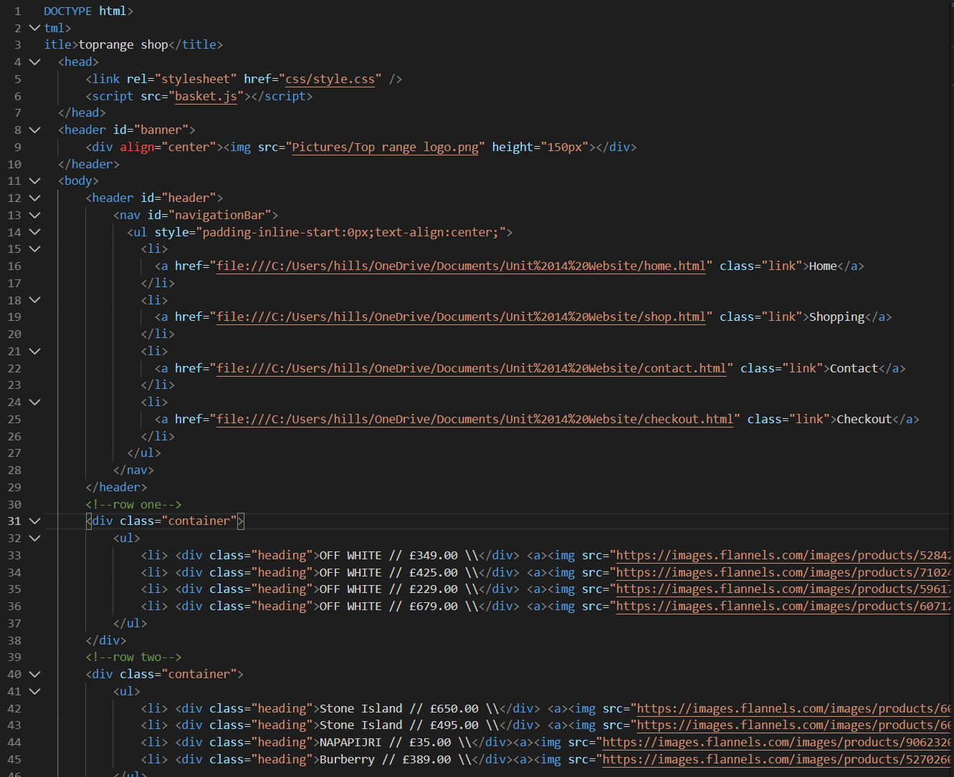
Shop

Contacts
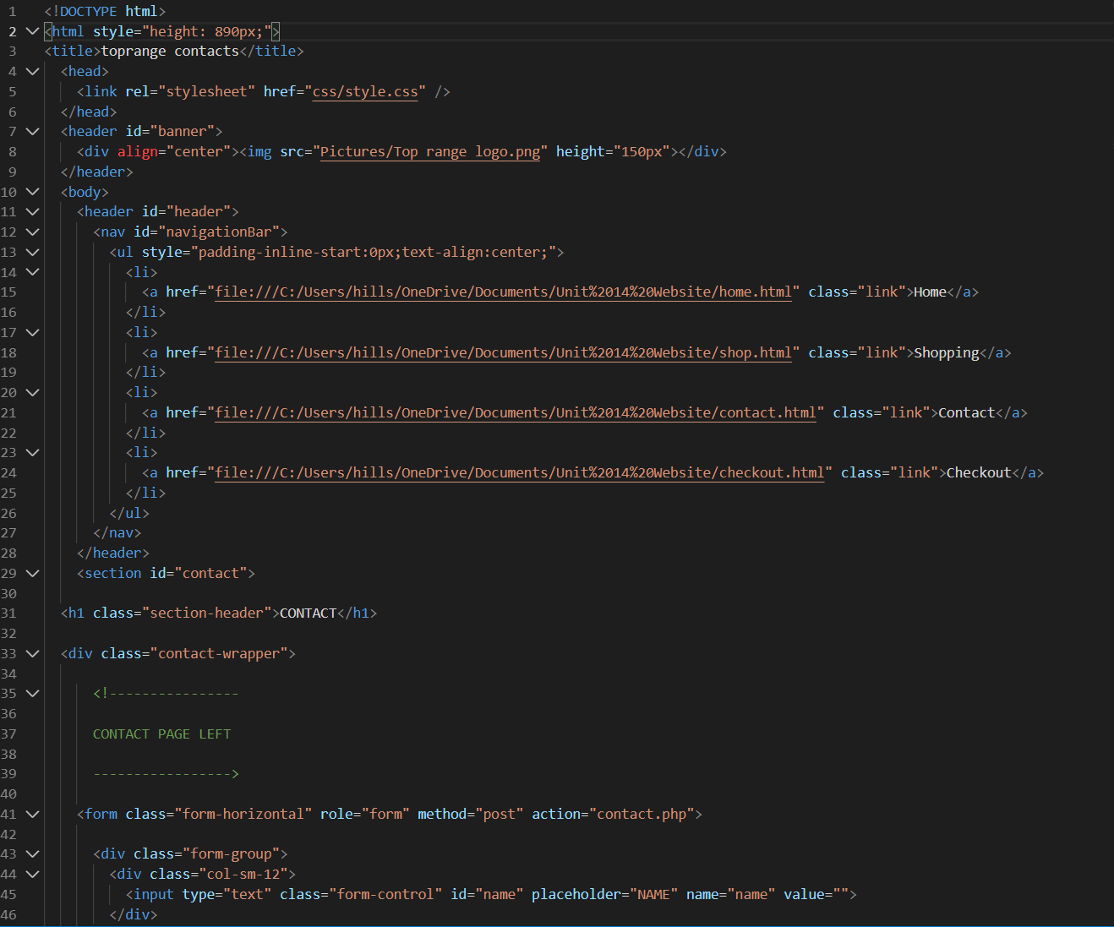
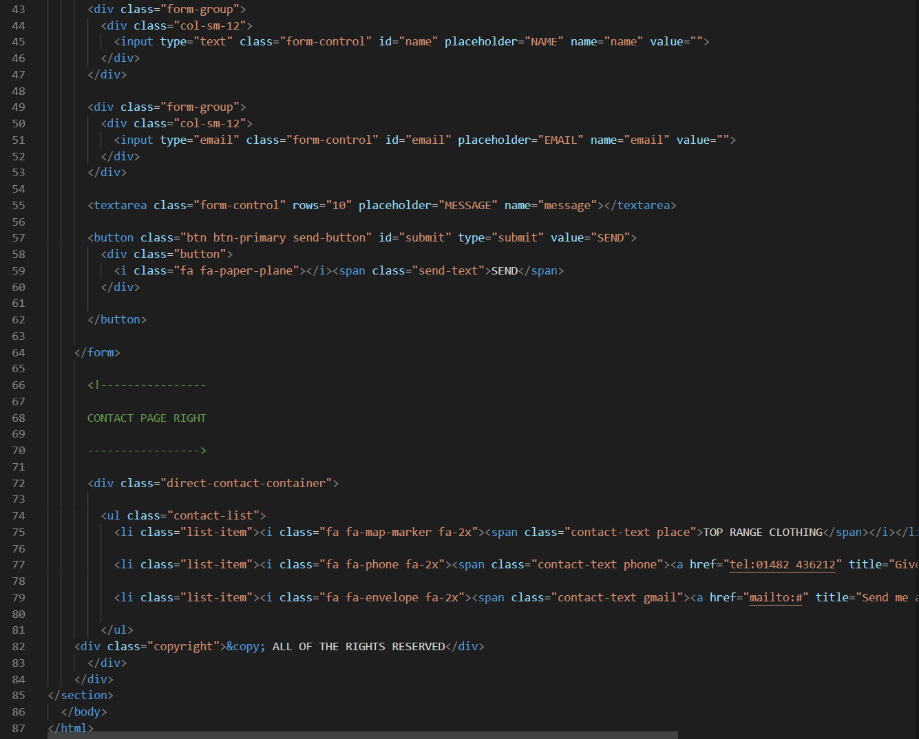

Checkout
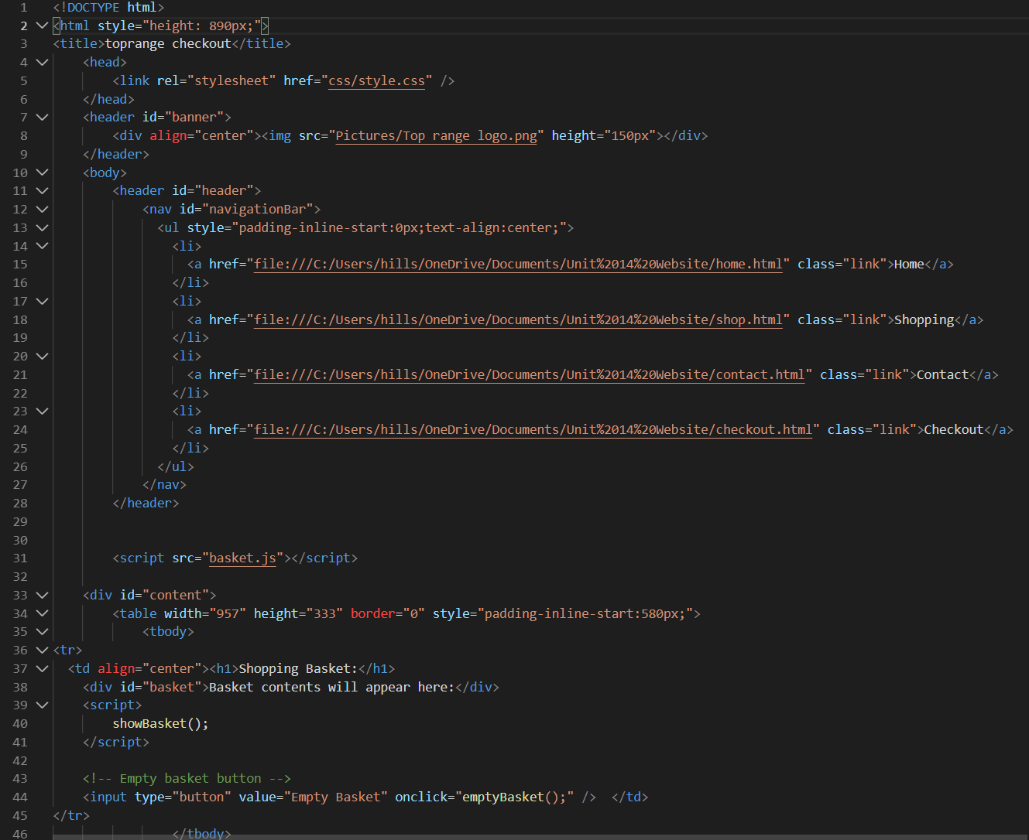

CSS
* {
font-family: monospace;
}

body {
background-image: linear-gradient(to bottom right,white,red);
}

#navigationBar {
background:#ff0000;
box-shadow:0px 1px 10px 10px #ddd;
height:auto;
text-align:50px;
width:100%;
text-align: center;
}

#navigationBar > ul > li {
display:inline;
text-align:center;
cursor: pointer;
}

#navigationBar > ul > li > a {
color:#fff;
display:inline-block;
height:60px;
line-height:60px;
margin:0px;
padding:0px 15px;
text-decoration:none;
transition: color 0.15s ease-in;
font-weight: 800;
text-align:center;
}

#navigationBar > ul > li > a:hover {
color:#000000;
}

.container{
width: 1500px;
height: 500px;
margin: 20px;
overflow: hidden;
margin-top: 20px;
margin-left: auto;
margin-right: auto;
}

.container ul{
padding: 0px;
margin: 0px;
}

.container ul li{
float:left;
list-style: none;
width:318px;
height:318px;
margin :70px 28px 40px 29px;
border:2px black;
box-sizing: border-box;
cursor: pointer;
}

.container ul li .heading{
width: 100%;
height:50px;
line-height: 50px;
text-align: center;
color: black;
font-size: 20px;
}
.container div{
font-family: monospace;
}

.pictures {
width: 318px;
height: 318px;
}

.pictures2 {
width: 300px;
height: 375px;
}

.logo {
width: 200px;
}

<!--home-->

.containerhome {
float:left;
list-style: none;
width:318px;
height:318px;
margin :20px 28px 40px 29px;
border:2px black;
box-sizing: border-box;
}

.containerhome ul{
padding: 0px;
margin: 0px;
}

.containerhome ul li{
float:left;
list-style: none;
width:318px;
height:318px;
margin :20px 28px 40px 29px;
border:2px black;
box-sizing: border-box;
}

.containerhome ul li .heading{
width: 100%;
height:50px;
line-height: 50px;
background: white;
text-align: center;
color: black;
font-size: 20px;
}

body {
margin: 0;
padding: 0;

}

#contact {
width: 100%;
height: 100vh;
overflow: hidden;
padding-bottom: 200px;
}

.section-header {
text-align: center;
margin: 0 auto;
padding-top: 50px;
margin-bottom: 50px;
font: 300 60px;
letter-spacing: 6px;
color: #000;
margin-bottom: 25px;
}

.contact-wrapper {
margin: 0 auto;
padding-top: 20px;
position: relative;
max-width: 800px;
}

/* Begin Left Contact Page */
.form-horizontal {
float: left;
max-width: 400px;
font-weight: 400;
}

.form-control, textarea {
max-width: 400px;
color: #000;
letter-spacing: 1px;
}

.send-button {
margin-top: 15px;
height: 34px;
width: 400px;
overflow: hidden;
transition: all .2s ease-in-out;
}

.button {
width: 400px;
height: 34px;
transition: all .2s ease-in-out;
}

.send-text {
display: block;
margin-top: 10px;
letter-spacing: 2px;
}

.button:hover {
transform: translate3d(0px, -29px, 0px);
}

/* Begin Right Contact Page */
.direct-contact-container {
max-width: 400px;
float: right;
margin-top: 5px;
}

/* Location, Phone, Email Section */
.contact-list {
list-style-type: none;
margin-left: -30px;
padding-right: 20px;
}

.list-item {
line-height: 4;
color: #aaa;
}

.contact-text {
letter-spacing: 1.9px;
color: #000;
}

.place {
margin-left: 62px;
}

.phone {
margin-left: 56px;
}

.gmail {
margin-left: 53px;
}

.contact-text a {
color: #000;
text-decoration: none;
transition-duration: 0.2s;
}

.contact-text a:hover {
color: #ff0000;
text-decoration: none;
}

/* Social Media Icons */
.social-media-list {
position: relative;
font-size: 2.3rem;
text-align: center;
width: 100%;
}

.social-media-list li {
position: relative;
top: 0;
left: -20px;
display: inline-block;
height: 70px;
width: 70px;
margin: 10px auto;
line-height: 70px;
border-radius: 50%;
color: #fff;
background-color: rgb(27,27,27);
cursor: pointer;
transition: all .2s ease-in-out;
}

.social-media-list li:after {
content: '';
position: absolute;
top: 0;
left: 0;
width: 70px;
height: 70px;
line-height: 70px;
border-radius: 50%;
opacity: 0;
box-shadow: 0 0 0 1px #fff;
transition: all .2s ease-in-out;
}

.social-media-list li:hover {
background-color: #fff;
}

.social-media-list li:hover:after {
opacity: 1;
transform: scale(1.12);
transition-timing-function: cubic-bezier(0.37,0.74,0.15,1.65);
}

.social-media-list li:hover a {
color: #111;
}

.copyright {
font: 200 14px;
color: #555;
letter-spacing: 1px;
text-align: center;
}

hr {
border-color: rgba(255,255,255,.8); ;
}

/* Begin Media Queries*/
@media screen and (max-width: 760px) {
#contact {
height: 1000px;
}
.section-header {
font-size: 65px;
}
.direct-contact-container, .form-horizontal {
float: none;
margin: 10px auto;
}
.direct-contact-container {
margin-top: 60px;
max-width: 300px;
}
.social-media-list li {
height: 60px;
width: 60px;
line-height: 60px;
}
.social-media-list li:after {
width: 60px;
height: 60px;
line-height: 60px;
}
}

@media screen and (max-width: 569px) {
#contact {
height: 1200px;
}
.section-header{
font-size: 50px;
}
.direct-contact-container, .form-wrapper {
float: none;
margin: 0 auto;
}
.form-control, textarea {
max-width: 340px;
margin: 0 auto;
}

.name, .email, textarea {
width: 280px;
}
.direct-contact-container {
margin-top: 60px;
max-width: 280px;
}
.social-media-list {
left: 0;
}
.social-media-list li {
height: 55px;
width: 55px;
line-height: 55px;
font-size: 2rem;
}
.social-media-list li:after {
width: 55px;
height: 55px;
line-height: 55px;
}

}

@media screen and (max-width: 410px) {
.send-button {
width: 99%;
}
}

Evaluation
The website came out better than I expected, the website has great functionality and flows well and everything looks formal and smart. There is a nice colour scheme, the photos in the website are all take from flannels website.
Flannels: https://www.flannels.com/
The website didn’t take long because I already had a template made up and I added more too it from what I had already made and added some detail to it with the background and the custom images on the home page etc.
There is four pages, a home page, shopping page, contacts and a checkout page, the home page has a very short description of what the company sells and shows what certain things are sold there, the shopping page has a small collection of what could and can be sold at Top Range Clothing, there are some very expensive clothing. The contact page allows you to contact the company and ask quires and find out about anything, obviously it goes nowhere because I haven’t sent anything up but it is all there to look at. The checkout page shows you what you have bought and it add it’s all up.

Screenshots

Home
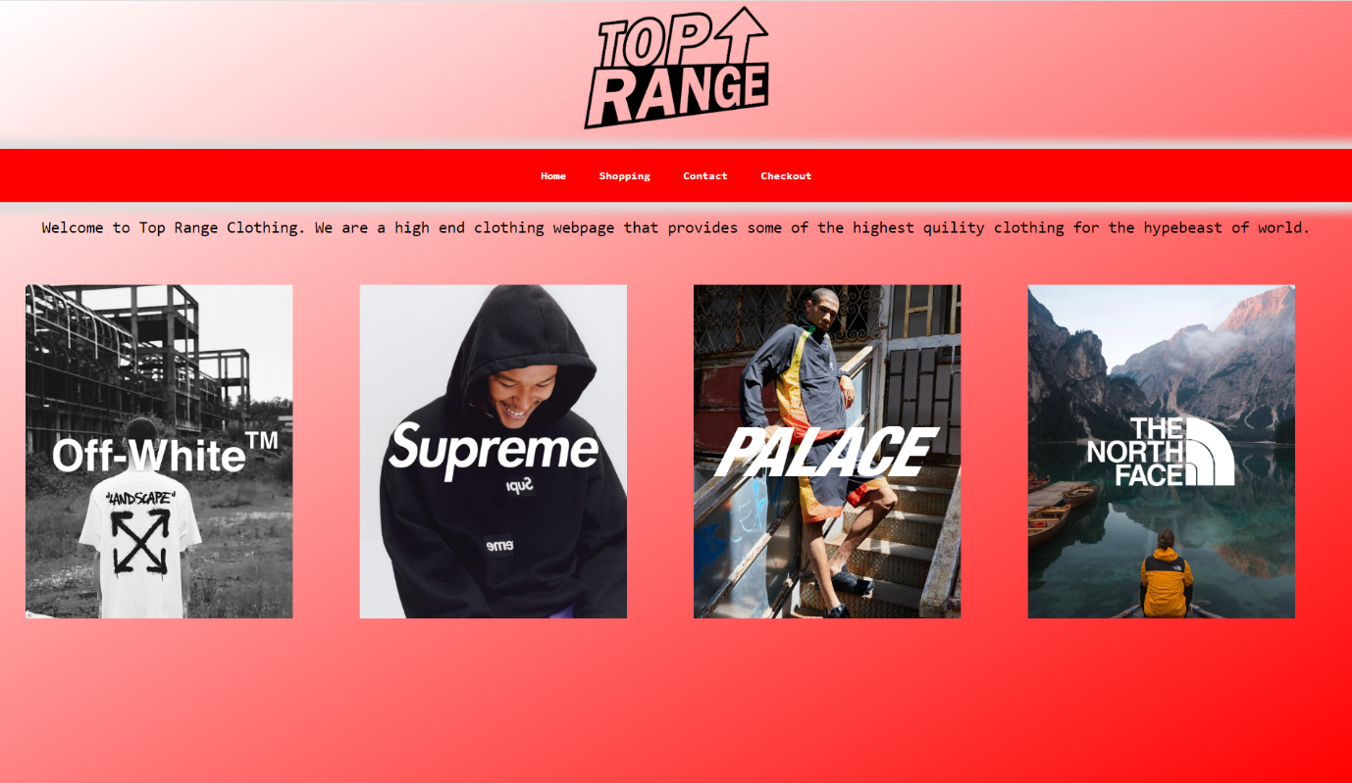

Shop
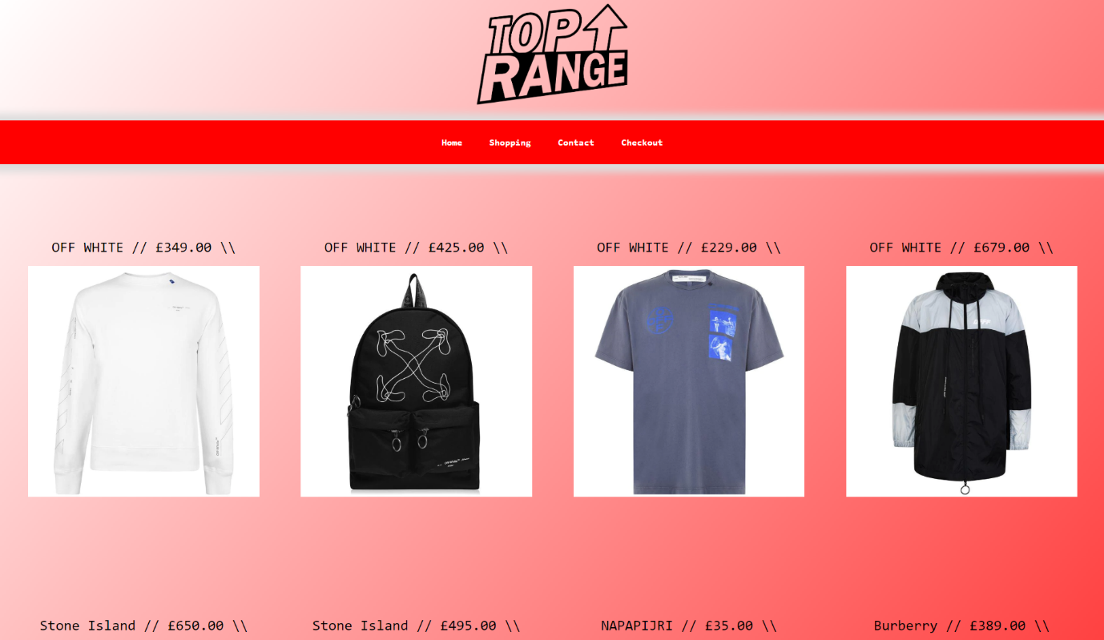

Contacts
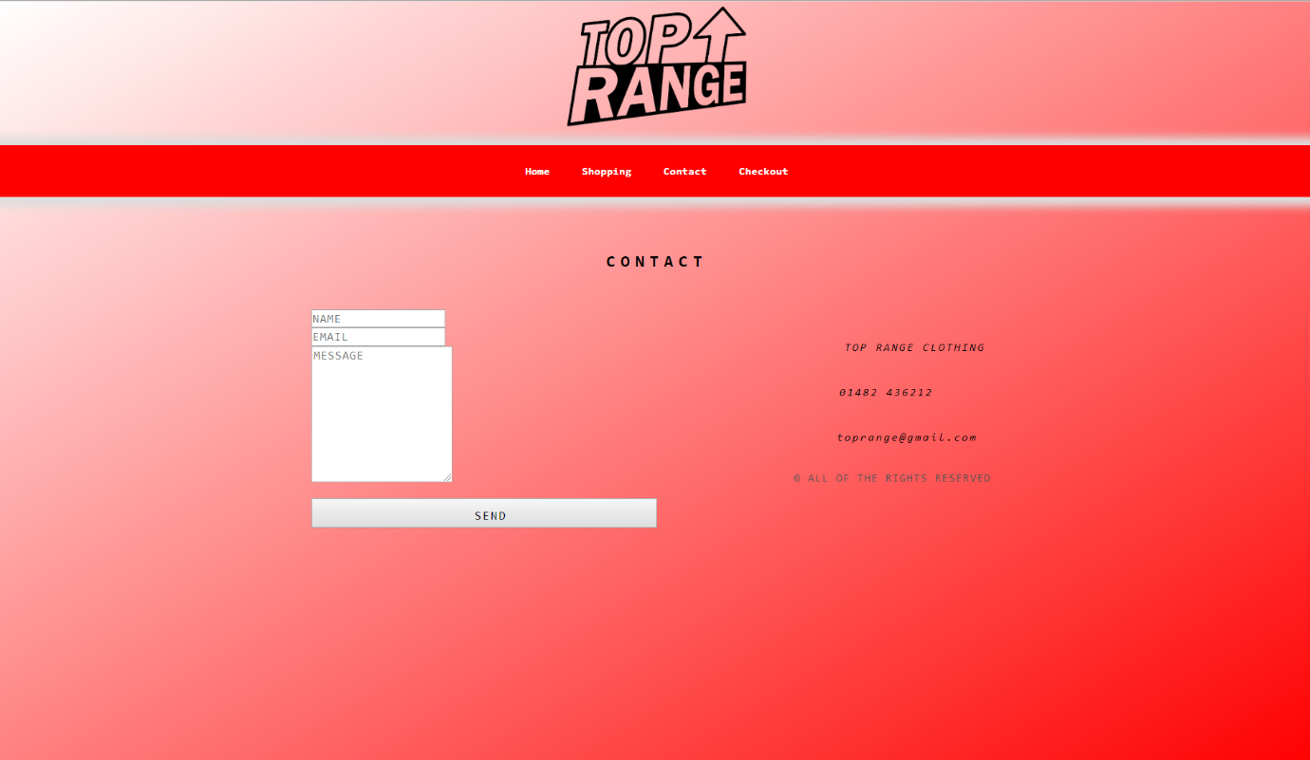

Basket
